YanPoDo USB DESKTOP READER/WRITER Software User Guide

1. Operating environment 2
2. Software Use 2
Open the device: 2
2.1 ParameterSet 4
2.11 Reader parameters 4
2.12 Reading settings 4
2.2 Read/Write 6
2.22 EPC Writing 7
2.23 Read and Write Operations 7
2.3 Active Mode 8

1. Operating environment
This software support system: Windows2000, Windows XP, Windows 7, Windows 8, Windows 10,Windows 2003 and higher systems.

- Software Use

Open the device:
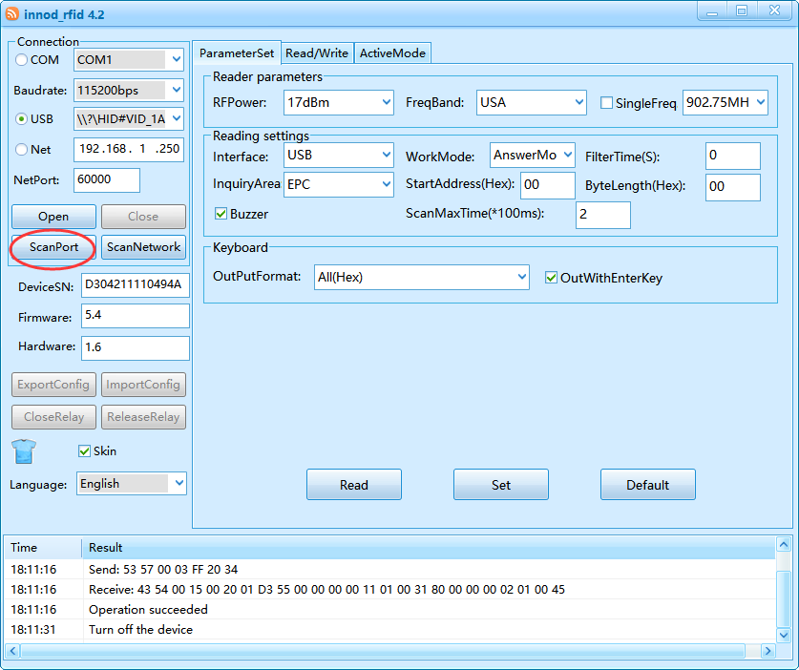

After the software is opened, please select the USB interface.

Note: If there is no corresponding device in the drop-down menu corresponding to the selected interface, please click the "ScanPort" button to scan the device.
Identifies if the device is connected properly.

After selecting the appropriate interface and filling in the correct settings, click the "Open" button if the device is connected properly and powered up. The software prompt "Open successfully" is as follows:
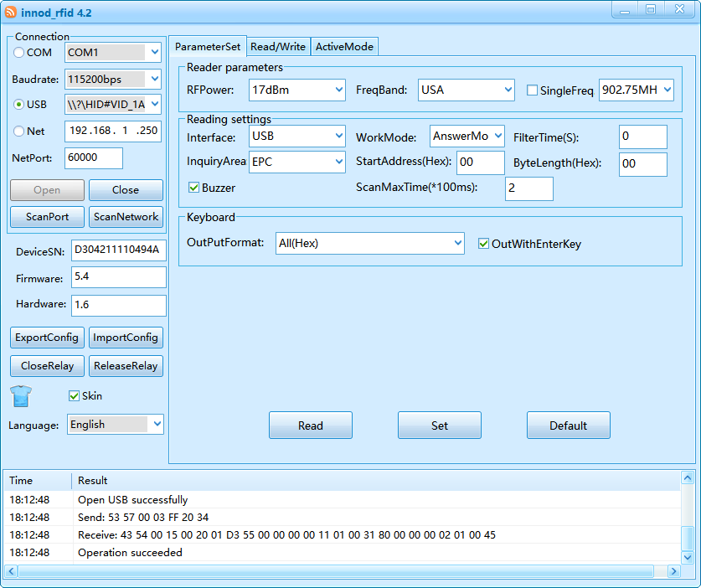

When turned on, the software can recognize the SN and version of the device, and can select different national languages.Supports Export Config、Import Config etc.
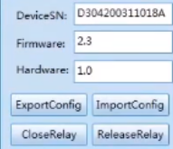

The window on the right has a total of 6 functions, as shown below:
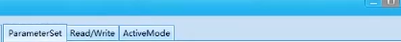
ParameterSet: set the parameters of the device.
Read/Write: card reading / writing operation.
Active mode: reading result of Active mode.

2.1 ParameterSet

2.11 Reader parameters
Reader parameters setting, including RFPower、FreBand、SingleFreq.
set and save power configuration.
select the reader’s band, different band, the frequency of different。
select single frequency

2.12 Reading settings
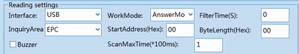
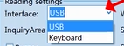select interface:USB or Keyboard.
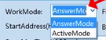select WorkMode:AnswerMode or ActiveMode.
set Filter time
select InquiryArea(EPC,TID,USER)
Set the start address and number of to be read,a word is 2 bytes.
set bytelength
Open or close the Buzzer.
Set the Scan Time.

2.13 TriggerEffective(Work under “keyboard”)
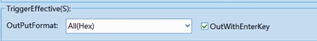
Can choose different output format.
Open or close output with Enter key.

2.14
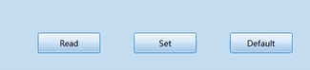
After selecting the parameters, click "Settings",the software will show “operation succeeded” then you can also select "Read", "Default". Operation time and result as shown below:
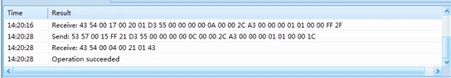

2.2 Read/Write
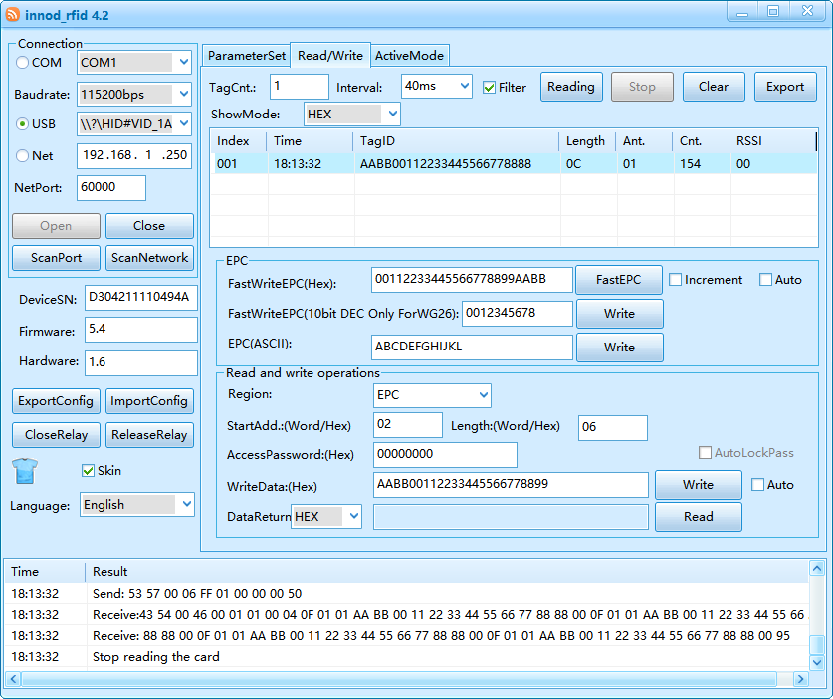

2.21 Basic Settings
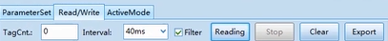
:Check the number of tags.
:Time interval for reading tags.
:Filter the same tags.
:start reading and stop reading.
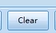:clear data.
:Export data.

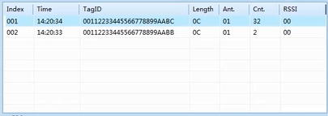
:Index.
:the time the device receives the tag.
:Tag card number, hexadecimal display.
:length of card number.
:Antenna port.
:The number of times the same ID was received after the filter function was turned on.
:RSSI value.

2.22 EPC Writing
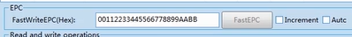
Fast Write EPC number.Support automatic or Increment card writing.

2.23 Read and Write Operations
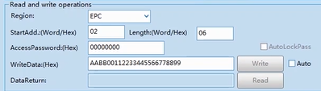
:Select Inquiry Area(EPC,TID,USER,RESERVED).
:Select Start address and set length
:Enter access password
:Start Write Data
:Data Return

2.3 Active Mode

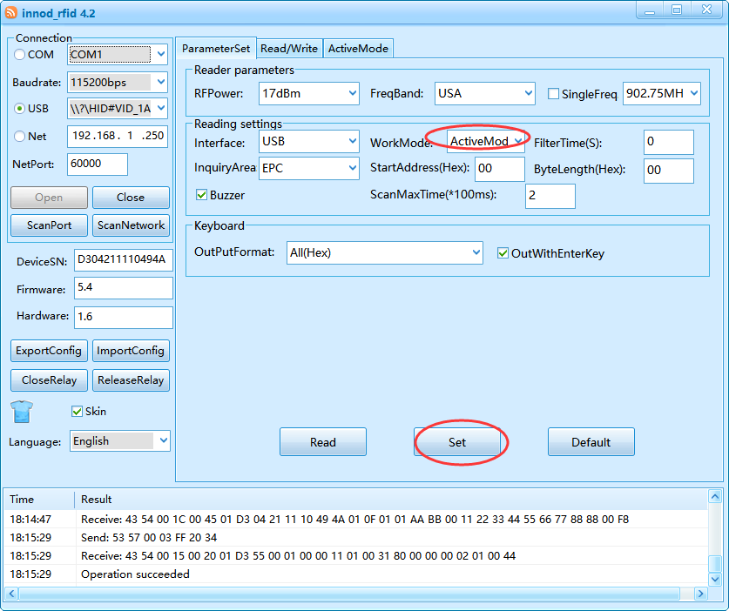
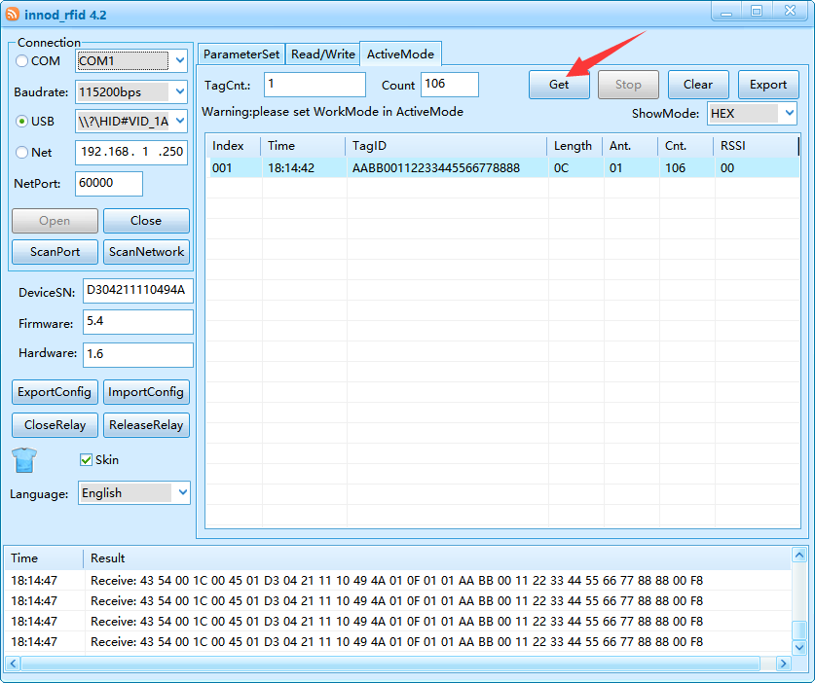

:Check the number of tags.
:Check the number tags has been read.
:Get and stop reading data.
:clear data.
:Export data.

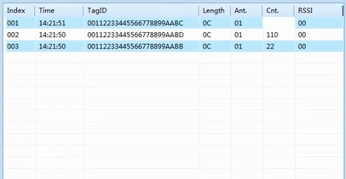
:Index.
:the time the device receives the tag.
:Tag card number, hexadecimal display.
:length of card number.
:Antenna port.
:The number of times the same ID was received after the filter function was turned on.
:RSSI value.

